**Objective Questions**

1. **Are there any tables with duplicate or missing null values? If so, how would you handle them?**

* Check each table in the Instagram clone database for:
* Missing or NULL values — where NOT NULL is not enforced.
* Duplicate entries — especially in tables without a PRIMARY KEY.
* CHECKING NULL VALUES:

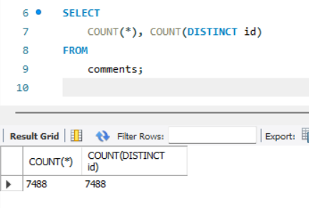 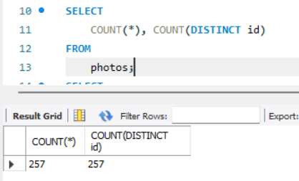

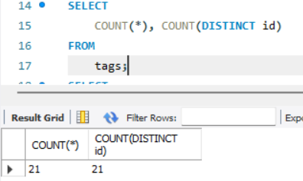 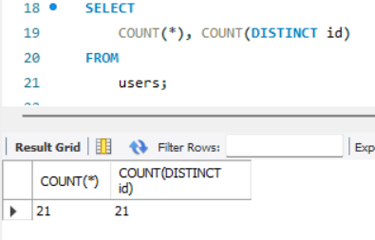

After comparing the total row count (COUNT(*)) with the number of distinct IDs (COUNT(DISTINCT id)) in the comments, photos, tags, and users tables, we observed that the counts are identical in each case. This confirms that all entries in these tables have unique primary key values, and there are no duplicate records.

* CHECKING DUPLICATE VALUES:

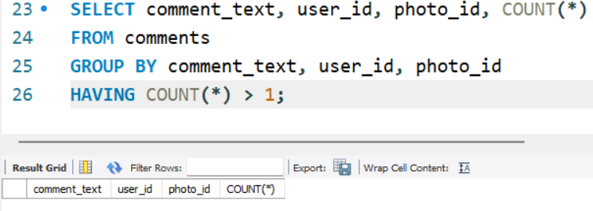

There are no duplicate comments with the same comment_text, by the same user_id, on the same photo_id.

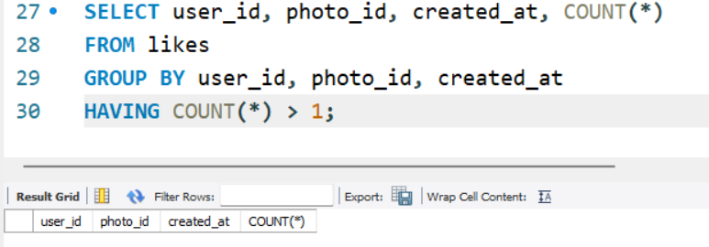

Each like by a user on a photo is unique per timestamp-

* Users aren’t liking the same post more than once.
* There is likely a one-like-per-photo-per-user restriction enforced (as defined by the composite primary key).

1. **What is the distribution of user activity levels (e.g., number of posts, likes, comments) across the user base?**

To analyze user activity levels, first calculate for each user:

* Number of posts they uploaded → From photos table
* Number of likes they gave → From likes table
* Number of comments they made → From comments table

Then, join these metrics on the users table to create a user-level summary. This will help identify:

* Highly active users vs low-engagement users
* User clusters (e.g., commenters but not likers)
* Segmentation for targeted marketing strategies

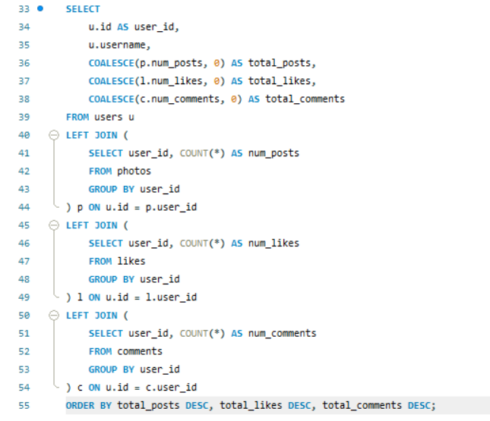

user_id, username, total_posts, total_likes, total_comments

|  |  |  |  |  |
| --- | --- | --- | --- | --- |
| 1 | Kenton_Kirlin | 5 | 0 | 0 |
| 2 | Andre_Purdy85 | 4 | 94 | 66 |
| 3 | Harley_Lind18 | 4 | 79 | 67 |
| 4 | Arely_Bogan63 | 3 | 93 | 64 |
| 5 | Aniya_Hackett | 0 | 257 | 257 |
| 6 | Travon.Waters | 5 | 82 | 62 |
| 7 | Kasandra_Homenick | 0 | 0 | 0 |
| 8 | Tabitha_Schamberger11 | 4 | 79 | 61 |
| 9 | Gus93 | 4 | 85 | 60 |
| 10 | Presley_McClure | 3 | 87 | 63 |
| 11 | Justina.Gaylord27 | 5 | 89 | 49 |
| 12 | Dereck65 | 4 | 77 | 68 |
| 13 | Alexandro35 | 5 | 93 | 58 |
| 14 | Jaclyn81 | 0 | 257 | 257 |
| 15 | Billy52 | 4 | 84 | 77 |
| 16 | Annalise.McKenzie16 | 4 | 103 | 52 |
| 17 | Norbert_Carroll35 | 3 | 78 | 83 |
| 18 | Odessa2 | 1 | 82 | 53 |
| 19 | Hailee26 | 2 | 90 | 60 |
| 20 | Delpha.Kihn | 1 | 87 | 67 |
| 21 | Rocio33 | 0 | 257 | 257 |
| 22 | Kenneth64 | 1 | 91 | 67 |
| 23 | Eveline95 | 12 | 0 | 0 |
| 24 | Maxwell.Halvorson | 0 | 257 | 257 |
| 25 | Tierra.Trantow | 0 | 0 | 0 |
| 26 | Josianne.Friesen | 5 | 94 | 69 |
| 27 | Darwin29 | 1 | 79 | 67 |
| 28 | Dario77 | 4 | 77 | 59 |
| 29 | Jaime53 | 8 | 0 | 0 |
| 30 | Kaley9 | 2 | 81 | 65 |
| 31 | Aiyana_Hoeger | 1 | 88 | 66 |
| 32 | Irwin.Larson | 4 | 91 | 56 |
| 33 | Yvette.Gottlieb91 | 5 | 77 | 61 |
| 34 | Pearl7 | 0 | 0 | 0 |
| 35 | Lennie_Hartmann40 | 2 | 92 | 67 |
| 36 | Ollie_Ledner37 | 0 | 257 | 257 |
| 37 | Yazmin_Mills95 | 1 | 84 | 63 |
| 38 | Jordyn.Jacobson2 | 2 | 85 | 58 |
| 39 | Kelsi26 | 1 | 89 | 67 |
| 40 | Rafael.Hickle2 | 1 | 85 | 68 |
| 41 | Mckenna17 | 0 | 257 | 257 |
| 42 | Maya.Farrell | 3 | 87 | 54 |
| 43 | Janet.Armstrong | 5 | 86 | 72 |
| 44 | Seth46 | 4 | 86 | 60 |
| 45 | David.Osinski47 | 0 | 0 | 0 |
| 46 | Malinda_Streich | 4 | 88 | 68 |
| 47 | Harrison.Beatty50 | 5 | 76 | 59 |
| 48 | Granville_Kutch | 1 | 75 | 55 |
| 49 | Morgan.Kassulke | 0 | 0 | 0 |
| 50 | Gerard79 | 3 | 81 | 69 |
| 51 | Mariano_Koch3 | 5 | 0 | 0 |
| 52 | Zack_Kemmer93 | 5 | 85 | 56 |
| 53 | Linnea59 | 0 | 0 | 0 |
| 54 | Duane60 | 0 | 257 | 257 |
| 55 | Meggie_Doyle | 1 | 78 | 66 |
| 56 | Peter.Stehr0 | 1 | 81 | 68 |
| 57 | Julien_Schmidt | 0 | 257 | 257 |
| 58 | Aurelie71 | 8 | 0 | 0 |
| 59 | Cesar93 | 10 | 0 | 0 |
| 60 | Sam52 | 2 | 86 | 72 |
| 61 | Jayson65 | 1 | 83 | 58 |
| 62 | Ressie_Stanton46 | 2 | 88 | 58 |
| 63 | Elenor88 | 4 | 83 | 80 |
| 64 | Florence99 | 5 | 0 | 0 |
| 65 | Adelle96 | 5 | 96 | 60 |
| 66 | Mike.Auer39 | 0 | 257 | 257 |
| 67 | Emilio_Bernier52 | 3 | 86 | 76 |
| 68 | Franco_Keebler64 | 0 | 0 | 0 |
| 69 | Karley_Bosco | 1 | 97 | 69 |
| 70 | Erick5 | 1 | 88 | 69 |
| 71 | Nia_Haag | 0 | 257 | 257 |
| 72 | Kathryn80 | 5 | 85 | 64 |
| 73 | Jaylan.Lakin | 1 | 86 | 63 |
| 74 | Hulda.Macejkovic | 0 | 0 | 0 |
| 75 | Leslie67 | 0 | 257 | 257 |
| 76 | Janelle.Nikolaus81 | 0 | 257 | 257 |
| 77 | Donald.Fritsch | 6 | 0 | 0 |
| 78 | Colten.Harris76 | 5 | 83 | 60 |
| 79 | Katarina.Dibbert | 1 | 75 | 68 |
| 80 | Darby_Herzog | 0 | 0 | 0 |
| 81 | Esther.Zulauf61 | 0 | 0 | 0 |
| 82 | Aracely.Johnston98 | 2 | 84 | 67 |
| 83 | Bartholome.Bernhard | 0 | 0 | 0 |
| 84 | Alysa22 | 2 | 75 | 76 |
| 85 | Milford_Gleichner42 | 2 | 87 | 57 |
| 86 | Delfina_VonRueden68 | 9 | 0 | 0 |
| 87 | Rick29 | 4 | 92 | 74 |
| 88 | Clint27 | 11 | 0 | 0 |
| 89 | Jessyca_West | 0 | 0 | 0 |
| 90 | Esmeralda.Mraz57 | 0 | 0 | 0 |
| 91 | Bethany20 | 0 | 257 | 257 |
| 92 | Frederik_Rice | 3 | 91 | 61 |
| 93 | Willie_Leuschke | 2 | 91 | 63 |
| 94 | Damon35 | 1 | 84 | 68 |
| 95 | Nicole71 | 2 | 86 | 68 |
| 96 | Keenan.Schamberger60 | 3 | 98 | 75 |
| 97 | Tomas.Beatty93 | 2 | 69 | 68 |
| 98 | Imani_Nicolas17 | 1 | 74 | 65 |
| 99 | Alek_Watsica | 3 | 74 | 68 |
| 100 | Javonte83 | 2 | 82 | 70 |

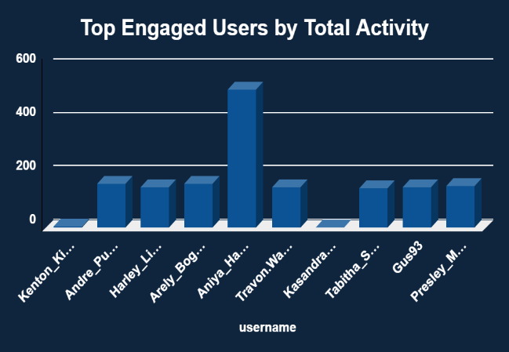 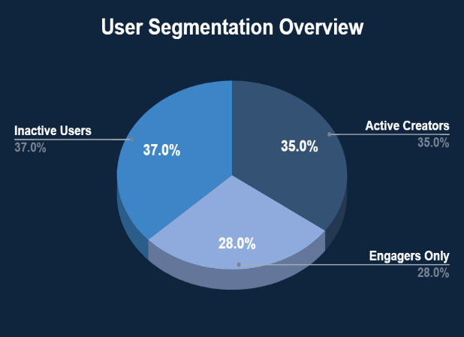

* Top users like *Aniya_Hackett* show exceptionally high engagement, making them ideal for influencer outreach or feature promotion. Others like *Andre_Purdy85* and *Travon.Waters* also display strong interaction levels. Segmentation reveals 35% active creators, 28% pure engagers, and 37% inactive users. This distribution highlights the need for creator support programs, campaigns to convert engagers into creators, and re-engagement strategies (e.g., personalized prompts) for inactive users. These insights can guide personalized marketing and platform growth initiatives.

1. **Calculate the average number of tags per post (photo_tags and photos tables).**

* To understand how effectively users are tagging their content, we calculated the average number of tags used per post. This was done by dividing the total number of tag associations in the photo_tags table by the total number of distinct photos in the photos table.

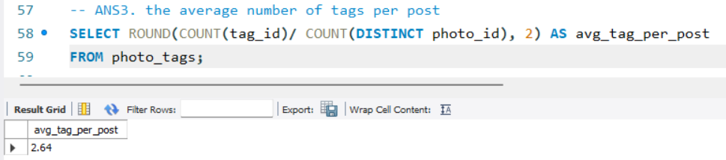

* The average of 2.64 tags per post indicates moderate usage of the tagging feature by users. While tagging is being adopted, there is still room for improvement. Encouraging users to add more relevant tags can enhance content discoverability, improve engagement through better recommendations, and boost visibility of user posts. Optimizing the tagging interface or educating users on the benefits of tagging could lead to more consistent and effective use of this feature across the platform.

1. **Identify the top users with the highest engagement rates (likes, comments) on their posts and rank them.**

To identify users with the highest engagement:

* Calculated the total number of likes and comments received per post for each user.
* Summed engagement across all their posts.
* Applied DENSE_RANK() to rank users from highest to lowest engagement.

This helps discover which users generate the most interaction on their content.

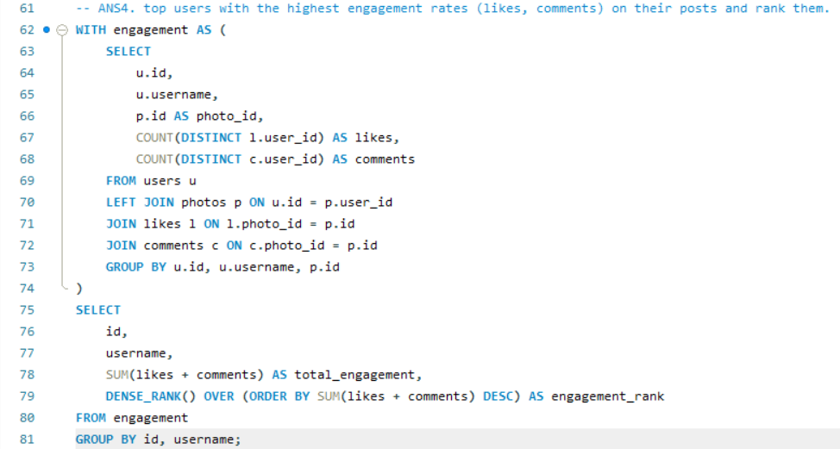

**id, username, total_engagement, engagement_rank**

|  |  |  |  |
| --- | --- | --- | --- |
| 23 | Eveline95 | 749 | 1 |
| 88 | Clint27 | 660 | 2 |
| 59 | Cesar93 | 646 | 3 |
| 86 | Delfina_VonRueden68 | 558 | 4 |
| 58 | Aurelie71 | 522 | 5 |
| 29 | Jaime53 | 500 | 6 |
| 77 | Donald.Fritsch | 392 | 7 |
| 43 | Janet.Armstrong | 334 | 8 |
| 52 | Zack_Kemmer93 | 333 | 9 |
| 13 | Alexandro35 | 329 | 10 |
| 65 | Adelle96 | 321 | 11 |
| 64 | Florence99 | 320 | 12 |
| 78 | Colten.Harris76 | 320 | 12 |
| 33 | Yvette.Gottlieb91 | 316 | 13 |
| 11 | Justina.Gaylord27 | 313 | 14 |
| 6 | Travon.Waters | 312 | 15 |
| 1 | Kenton_Kirlin | 310 | 16 |
| 26 | Josianne.Friesen | 309 | 17 |
| 51 | Mariano_Koch3 | 305 | 18 |
| 72 | Kathryn80 | 305 | 18 |
| 47 | Harrison.Beatty50 | 297 | 19 |
| 87 | Rick29 | 272 | 20 |
| 46 | Malinda_Streich | 266 | 21 |
| 44 | Seth46 | 264 | 22 |
| 16 | Annalise.McKenzie16 | 263 | 23 |
| 63 | Elenor88 | 258 | 24 |
| 32 | Irwin.Larson | 258 | 24 |
| 12 | Dereck65 | 257 | 25 |
| 9 | Gus93 | 256 | 26 |
| 8 | Tabitha_Schamberger11 | 256 | 26 |
| 28 | Dario77 | 252 | 27 |
| 3 | Harley_Lind18 | 249 | 28 |
| 2 | Andre_Purdy85 | 246 | 29 |
| 15 | Billy52 | 244 | 30 |
| 96 | Keenan.Schamberger60 | 197 | 31 |
| 10 | Presley_McClure | 195 | 32 |
| 17 | Norbert_Carroll35 | 191 | 33 |
| 42 | Maya.Farrell | 190 | 34 |
| 92 | Frederik_Rice | 190 | 34 |
| 50 | Gerard79 | 186 | 35 |
| 67 | Emilio_Bernier52 | 184 | 36 |
| 4 | Arely_Bogan63 | 183 | 37 |
| 99 | Alek_Watsica | 177 | 38 |
| 82 | Aracely.Johnston98 | 133 | 39 |
| 62 | Ressie_Stanton46 | 132 | 40 |
| 100 | Javonte83 | 130 | 41 |
| 84 | Alysa22 | 128 | 42 |
| 19 | Hailee26 | 125 | 43 |
| 93 | Willie_Leuschke | 125 | 43 |
| 30 | Kaley9 | 124 | 44 |
| 38 | Jordyn.Jacobson2 | 122 | 45 |
| 35 | Lennie_Hartmann40 | 122 | 45 |
| 60 | Sam52 | 121 | 46 |
| 95 | Nicole71 | 119 | 47 |
| 85 | Milford_Gleichner42 | 115 | 48 |
| 97 | Tomas.Beatty93 | 106 | 49 |
| 55 | Meggie_Doyle | 75 | 50 |
| 73 | Jaylan.Lakin | 73 | 51 |
| 48 | Granville_Kutch | 71 | 52 |
| 22 | Kenneth64 | 70 | 53 |
| 69 | Karley_Bosco | 68 | 54 |
| 94 | Damon35 | 68 | 54 |
| 18 | Odessa2 | 67 | 55 |
| 39 | Kelsi26 | 66 | 56 |
| 61 | Jayson65 | 66 | 56 |
| 37 | Yazmin_Mills95 | 65 | 57 |
| 20 | Delpha.Kihn | 65 | 57 |
| 70 | Erick5 | 65 | 57 |
| 27 | Darwin29 | 64 | 58 |
| 31 | Aiyana_Hoeger | 63 | 59 |
| 56 | Peter.Stehr0 | 61 | 60 |
| 40 | Rafael.Hickle2 | 59 | 61 |
| 79 | Katarina.Dibbert | 59 | 61 |
| 98 | Imani_Nicolas17 | 58 | 62 |

1. **Which users have the highest number of followers and followings?**

* To identify the user has the highest number of followers and followings first use the follows table:

follower_id → who follows others (followings)

followee_id → who is being followed (followers)

* Then for each user, calculate Total followers and Total followings.
* Use DENSE_RANK() to rank users based on both metrics.
* Filter for users who are ranked 1 (top) in either category.

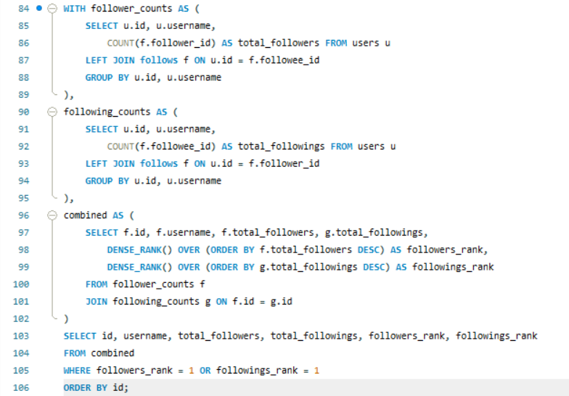

**i**d, username, total_followers, total_followings, followers_rank, followings_rank

|  |  |  |  |  |  |
| --- | --- | --- | --- | --- | --- |
| 1 | Kenton_Kirlin | 77 | 0 | 1 | 2 |
| 2 | Andre_Purdy85 | 76 | 99 | 2 | 1 |
| 3 | Harley_Lind18 | 76 | 99 | 2 | 1 |
| 4 | Arely_Bogan63 | 76 | 99 | 2 | 1 |
| 5 | Aniya_Hackett | 76 | 99 | 2 | 1 |
| 6 | Travon.Waters | 76 | 99 | 2 | 1 |
| 7 | Kasandra_Homenick | 77 | 0 | 1 | 2 |
| 8 | Tabitha_Schamberger11 | 76 | 99 | 2 | 1 |
| 9 | Gus93 | 76 | 99 | 2 | 1 |
| 10 | Presley_McClure | 76 | 99 | 2 | 1 |
| 11 | Justina.Gaylord27 | 76 | 99 | 2 | 1 |
| 12 | Dereck65 | 76 | 99 | 2 | 1 |
| 13 | Alexandro35 | 76 | 99 | 2 | 1 |
| 14 | Jaclyn81 | 76 | 99 | 2 | 1 |
| 15 | Billy52 | 76 | 99 | 2 | 1 |
| 16 | Annalise.McKenzie16 | 76 | 99 | 2 | 1 |
| 17 | Norbert_Carroll35 | 76 | 99 | 2 | 1 |
| 18 | Odessa2 | 76 | 99 | 2 | 1 |
| 19 | Hailee26 | 76 | 99 | 2 | 1 |
| 20 | Delpha.Kihn | 76 | 99 | 2 | 1 |
| 21 | Rocio33 | 76 | 99 | 2 | 1 |
| 22 | Kenneth64 | 76 | 99 | 2 | 1 |
| 23 | Eveline95 | 77 | 0 | 1 | 2 |
| 24 | Maxwell.Halvorson | 76 | 99 | 2 | 1 |
| 25 | Tierra.Trantow | 77 | 0 | 1 | 2 |
| 26 | Josianne.Friesen | 76 | 99 | 2 | 1 |
| 27 | Darwin29 | 76 | 99 | 2 | 1 |
| 28 | Dario77 | 76 | 99 | 2 | 1 |
| 29 | Jaime53 | 77 | 0 | 1 | 2 |
| 30 | Kaley9 | 76 | 99 | 2 | 1 |
| 31 | Aiyana_Hoeger | 76 | 99 | 2 | 1 |
| 32 | Irwin.Larson | 76 | 99 | 2 | 1 |
| 33 | Yvette.Gottlieb91 | 76 | 99 | 2 | 1 |
| 34 | Pearl7 | 77 | 0 | 1 | 2 |
| 35 | Lennie_Hartmann40 | 76 | 99 | 2 | 1 |
| 36 | Ollie_Ledner37 | 76 | 99 | 2 | 1 |
| 37 | Yazmin_Mills95 | 76 | 99 | 2 | 1 |
| 38 | Jordyn.Jacobson2 | 76 | 99 | 2 | 1 |
| 39 | Kelsi26 | 76 | 99 | 2 | 1 |
| 40 | Rafael.Hickle2 | 76 | 99 | 2 | 1 |
| 41 | Mckenna17 | 76 | 99 | 2 | 1 |
| 42 | Maya.Farrell | 76 | 99 | 2 | 1 |
| 43 | Janet.Armstrong | 76 | 99 | 2 | 1 |
| 44 | Seth46 | 76 | 99 | 2 | 1 |
| 45 | David.Osinski47 | 77 | 0 | 1 | 2 |
| 46 | Malinda_Streich | 76 | 99 | 2 | 1 |
| 47 | Harrison.Beatty50 | 76 | 99 | 2 | 1 |
| 48 | Granville_Kutch | 76 | 99 | 2 | 1 |
| 49 | Morgan.Kassulke | 77 | 0 | 1 | 2 |
| 50 | Gerard79 | 76 | 99 | 2 | 1 |
| 51 | Mariano_Koch3 | 77 | 0 | 1 | 2 |
| 52 | Zack_Kemmer93 | 76 | 99 | 2 | 1 |
| 53 | Linnea59 | 77 | 0 | 1 | 2 |
| 54 | Duane60 | 76 | 99 | 2 | 1 |
| 55 | Meggie_Doyle | 76 | 99 | 2 | 1 |
| 56 | Peter.Stehr0 | 76 | 99 | 2 | 1 |
| 57 | Julien_Schmidt | 76 | 99 | 2 | 1 |
| 58 | Aurelie71 | 77 | 0 | 1 | 2 |
| 59 | Cesar93 | 77 | 0 | 1 | 2 |
| 60 | Sam52 | 76 | 99 | 2 | 1 |
| 61 | Jayson65 | 76 | 99 | 2 | 1 |
| 62 | Ressie_Stanton46 | 76 | 99 | 2 | 1 |
| 63 | Elenor88 | 76 | 99 | 2 | 1 |
| 64 | Florence99 | 77 | 0 | 1 | 2 |
| 65 | Adelle96 | 76 | 99 | 2 | 1 |
| 66 | Mike.Auer39 | 76 | 99 | 2 | 1 |
| 67 | Emilio_Bernier52 | 76 | 99 | 2 | 1 |
| 68 | Franco_Keebler64 | 77 | 0 | 1 | 2 |
| 69 | Karley_Bosco | 76 | 99 | 2 | 1 |
| 70 | Erick5 | 76 | 99 | 2 | 1 |
| 71 | Nia_Haag | 76 | 99 | 2 | 1 |
| 72 | Kathryn80 | 76 | 99 | 2 | 1 |
| 73 | Jaylan.Lakin | 76 | 99 | 2 | 1 |
| 74 | Hulda.Macejkovic | 77 | 0 | 1 | 2 |
| 75 | Leslie67 | 76 | 99 | 2 | 1 |
| 76 | Janelle.Nikolaus81 | 76 | 99 | 2 | 1 |
| 77 | Donald.Fritsch | 77 | 0 | 1 | 2 |
| 78 | Colten.Harris76 | 76 | 99 | 2 | 1 |
| 79 | Katarina.Dibbert | 76 | 99 | 2 | 1 |
| 80 | Darby_Herzog | 77 | 0 | 1 | 2 |
| 81 | Esther.Zulauf61 | 77 | 0 | 1 | 2 |
| 82 | Aracely.Johnston98 | 76 | 99 | 2 | 1 |
| 83 | Bartholome.Bernhard | 77 | 0 | 1 | 2 |
| 84 | Alysa22 | 76 | 99 | 2 | 1 |
| 85 | Milford_Gleichner42 | 76 | 99 | 2 | 1 |
| 86 | Delfina_VonRueden68 | 77 | 0 | 1 | 2 |
| 87 | Rick29 | 76 | 99 | 2 | 1 |
| 88 | Clint27 | 77 | 0 | 1 | 2 |
| 89 | Jessyca_West | 77 | 0 | 1 | 2 |
| 90 | Esmeralda.Mraz57 | 77 | 0 | 1 | 2 |
| 91 | Bethany20 | 76 | 99 | 2 | 1 |
| 92 | Frederik_Rice | 76 | 99 | 2 | 1 |
| 93 | Willie_Leuschke | 76 | 99 | 2 | 1 |
| 94 | Damon35 | 76 | 99 | 2 | 1 |
| 95 | Nicole71 | 76 | 99 | 2 | 1 |
| 96 | Keenan.Schamberger60 | 76 | 99 | 2 | 1 |
| 97 | Tomas.Beatty93 | 76 | 99 | 2 | 1 |
| 98 | Imani_Nicolas17 | 76 | 99 | 2 | 1 |
| 99 | Alek_Watsica | 76 | 99 | 2 | 1 |
| 100 | Javonte83 | 76 | 99 | 2 | 1 |

* The analysis shows that many users have exactly 76 followers and 99 followings, indicating a highly uniform social graph. This suggests either a synthetic test dataset or behavior driven by automatic mutual following (follow-backs). Interestingly, a few users have 77 followers and 0 followings, which may represent influential users or default non-engaged accounts. These highly followed but non-following users can be classified as influencer-type profiles or system-generated entities. Identifying and segmenting such users helps in analyzing organic vs artificial engagement and in refining follow-suggestion algorithms or marketing targeting strategies.

1. **Calculate the average engagement rate (likes, comments) per post for each user.**

To evaluate how engaging a user’s content is on average:

* Define engagement per post as (likes + comments)
* Calculate average engagement per post per user
* Aggregate post-level engagement and use AVG() at the user level
* Only include users with at least one post

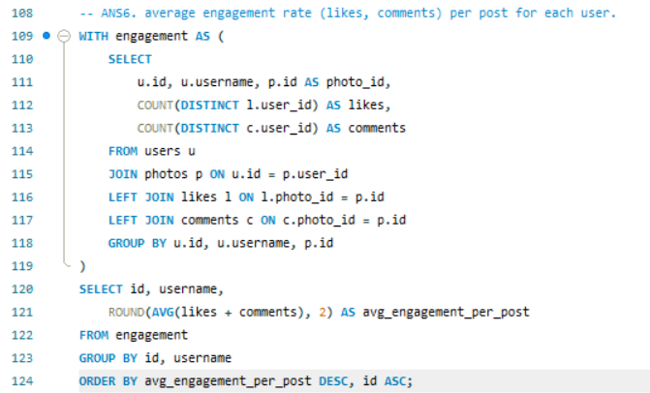

id, username, avg_engagement_per_post

|  |  |  |
| --- | --- | --- |
| 55 | Meggie_Doyle | 75.00 |
| 73 | Jaylan.Lakin | 73.00 |
| 48 | Granville_Kutch | 71.00 |
| 22 | Kenneth64 | 70.00 |
| 69 | Karley_Bosco | 68.00 |
| 87 | Rick29 | 68.00 |
| 94 | Damon35 | 68.00 |
| 18 | Odessa2 | 67.00 |
| 43 | Janet.Armstrong | 66.80 |
| 52 | Zack_Kemmer93 | 66.60 |
| 46 | Malinda_Streich | 66.50 |
| 82 | Aracely.Johnston98 | 66.50 |
| 39 | Kelsi26 | 66.00 |
| 44 | Seth46 | 66.00 |
| 61 | Jayson65 | 66.00 |
| 62 | Ressie_Stanton46 | 66.00 |
| 13 | Alexandro35 | 65.80 |
| 16 | Annalise.McKenzie16 | 65.75 |
| 96 | Keenan.Schamberger60 | 65.67 |
| 77 | Donald.Fritsch | 65.33 |
| 58 | Aurelie71 | 65.25 |
| 10 | Presley_McClure | 65.00 |
| 20 | Delpha.Kihn | 65.00 |
| 37 | Yazmin_Mills95 | 65.00 |
| 70 | Erick5 | 65.00 |
| 100 | Javonte83 | 65.00 |
| 59 | Cesar93 | 64.60 |
| 32 | Irwin.Larson | 64.50 |
| 63 | Elenor88 | 64.50 |
| 12 | Dereck65 | 64.25 |
| 65 | Adelle96 | 64.20 |
| 8 | Tabitha_Schamberger11 | 64.00 |
| 9 | Gus93 | 64.00 |
| 27 | Darwin29 | 64.00 |
| 64 | Florence99 | 64.00 |
| 78 | Colten.Harris76 | 64.00 |
| 84 | Alysa22 | 64.00 |
| 17 | Norbert_Carroll35 | 63.67 |
| 42 | Maya.Farrell | 63.33 |
| 92 | Frederik_Rice | 63.33 |
| 33 | Yvette.Gottlieb91 | 63.20 |
| 28 | Dario77 | 63.00 |
| 31 | Aiyana_Hoeger | 63.00 |
| 11 | Justina.Gaylord27 | 62.60 |
| 19 | Hailee26 | 62.50 |
| 29 | Jaime53 | 62.50 |
| 93 | Willie_Leuschke | 62.50 |
| 23 | Eveline95 | 62.42 |
| 6 | Travon.Waters | 62.40 |
| 3 | Harley_Lind18 | 62.25 |
| 1 | Kenton_Kirlin | 62.00 |
| 30 | Kaley9 | 62.00 |
| 50 | Gerard79 | 62.00 |
| 86 | Delfina_VonRueden68 | 62.00 |
| 26 | Josianne.Friesen | 61.80 |
| 2 | Andre_Purdy85 | 61.50 |
| 67 | Emilio_Bernier52 | 61.33 |
| 4 | Arely_Bogan63 | 61.00 |
| 15 | Billy52 | 61.00 |
| 35 | Lennie_Hartmann40 | 61.00 |
| 38 | Jordyn.Jacobson2 | 61.00 |
| 51 | Mariano_Koch3 | 61.00 |
| 56 | Peter.Stehr0 | 61.00 |
| 72 | Kathryn80 | 61.00 |
| 60 | Sam52 | 60.50 |
| 88 | Clint27 | 60.00 |
| 95 | Nicole71 | 59.50 |
| 47 | Harrison.Beatty50 | 59.40 |
| 40 | Rafael.Hickle2 | 59.00 |
| 79 | Katarina.Dibbert | 59.00 |
| 99 | Alek_Watsica | 59.00 |
| 98 | Imani_Nicolas17 | 58.00 |
| 85 | Milford_Gleichner42 | 57.50 |
| 97 | Tomas.Beatty93 | 53.00 |

* Users like *Meggie_Doyle* and *Jaylan.Lakin* have the highest average engagement per post, indicating their content strongly resonates with the audience. These users are ideal for targeted promotions or influencer campaigns, while those with lower averages may need support to improve content reach or quality.

1. **Get the list of users who have never liked any post (users and likes tables)**

To find users with no likes activity:

* Join users with likes using a LEFT JOIN on user_id
* Group the result by user ID and username
* Use HAVING COUNT(DISTINCT photo_id) = 0 to filter those who haven’t liked any post.

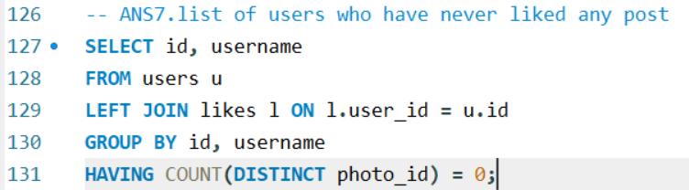

id, username

|  |  |
| --- | --- |
| 1 | Kenton_Kirlin |
| 7 | Kasandra_Homenick |
| 23 | Eveline95 |
| 25 | Tierra.Trantow |
| 29 | Jaime53 |
| 34 | Pearl7 |
| 45 | David.Osinski47 |
| 49 | Morgan.Kassulke |
| 51 | Mariano_Koch3 |
| 53 | Linnea59 |
| 58 | Aurelie71 |
| 59 | Cesar93 |
| 64 | Florence99 |
| 68 | Franco_Keebler64 |
| 74 | Hulda.Macejkovic |
| 77 | Donald.Fritsch |
| 80 | Darby_Herzog |
| 81 | Esther.Zulauf61 |
| 83 | Bartholome.Bernhard |
| 86 | Delfina_VonRueden68 |
| 88 | Clint27 |
| 89 | Jessyca_West |
| 90 | Esmeralda.Mraz57 |

* These users have never liked any post, indicating low or passive engagement. They may be inactive, new, or content viewers only. Targeted prompts, interactive features, or personalized content recommendations can help activate their participation and improve overall platform engagement.

1. **How can you leverage user-generated content (posts, hashtags, photo tags) to create more personalized and engaging ad campaigns?**

* To use user-generated content for personalized ad targeting:
* Analyze which tags (topics or categories) are used most across photos
* Measure:
  + Number of posts per tag
  + Number of unique users using that tag
  + Number of likes received on posts with that tag
* This help identify popular interests, active communities, and high-engagement content themes
* Use results to design interest-based ad segments

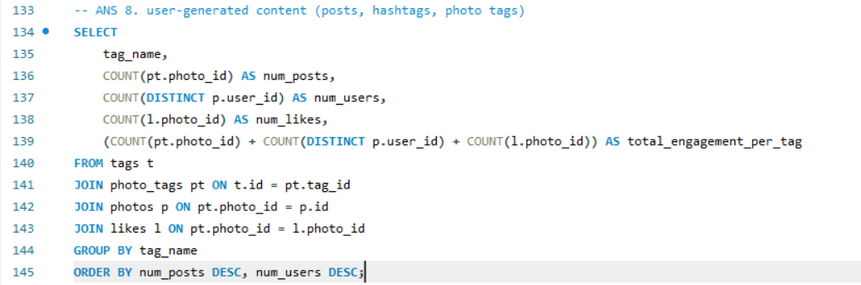

* tag_name, num_posts, num_users, num_likes, total_engagement_per_tag

|  |  |  |  |  |
| --- | --- | --- | --- | --- |
| smile | 2033 | 37 | 2033 | 4103 |
| beach | 1448 | 33 | 1448 | 2929 |
| party | 1323 | 29 | 1323 | 2675 |
| fun | 1301 | 26 | 1301 | 2628 |
| concert | 825 | 21 | 825 | 1671 |
| lol | 821 | 20 | 821 | 1662 |
| food | 812 | 20 | 812 | 1644 |
| hair | 794 | 16 | 794 | 1604 |
| happy | 761 | 20 | 761 | 1542 |
| dreamy | 715 | 15 | 715 | 1445 |
| beauty | 699 | 16 | 699 | 1414 |
| sunset | 650 | 15 | 650 | 1315 |
| drunk | 647 | 17 | 647 | 1311 |
| fashion | 640 | 15 | 640 | 1295 |
| style | 586 | 15 | 586 | 1187 |
| sunrise | 574 | 13 | 574 | 1161 |
| landscape | 571 | 16 | 571 | 1158 |
| stunning | 559 | 13 | 559 | 1131 |
| photography | 552 | 14 | 552 | 1118 |
| delicious | 524 | 13 | 524 | 1061 |
| foodie | 382 | 10 | 382 | 774 |

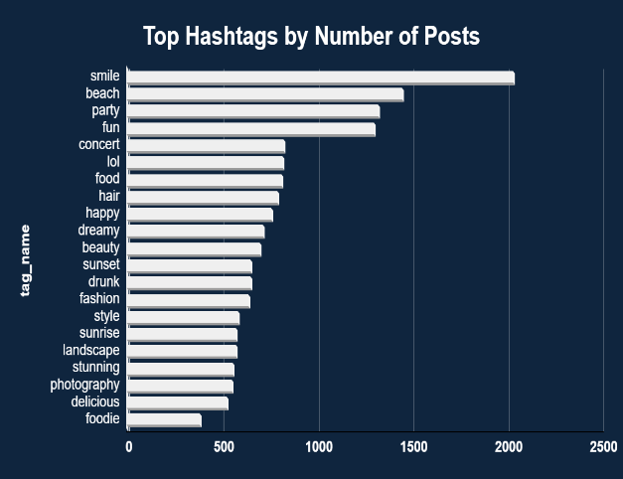 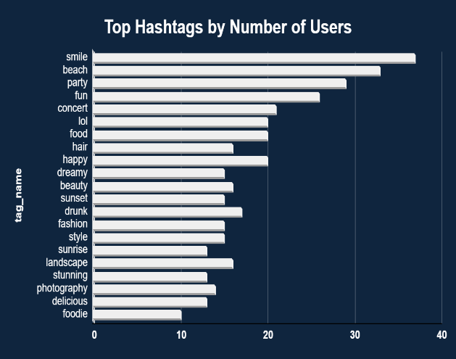

* Tags like **#smile**, **#beach**, **#party**, and **#fun** consistently lead in both number of posts and unique user participation. This indicates these topics are not only popular in volume but also widely adopted by the user base, suggesting they resonate broadly. In contrast, tags like **#foodie**, **#delicious**, and **#photography** show moderate to high engagement but are used by fewer users, hinting at niche but dedicated communities. These insights can guide marketers in selecting high-reach hashtags for broad appeal or niche ones for targeted campaigns.

1. **Are there any correlations between user activity levels and specific content types (e.g., photos, videos, reels)? How can this information guide content creation and curation strategies?**

* To analyze how different content activities contribute to overall user engagement:
* Break down engagement by:
  + Posts made by the user (photos)
  + Likes given (likes)
  + Comments made (comments)
* For each user:
  + Calculate total engagement as the sum of their likes, comments, and posts.
  + Compute the percentage share of each activity type.
* Rank users based on total engagement percent and activity share to identify top contributors and their dominant behaviors.

This helps understand what drives user engagement and how to tailor content formats and strategies accordingly.

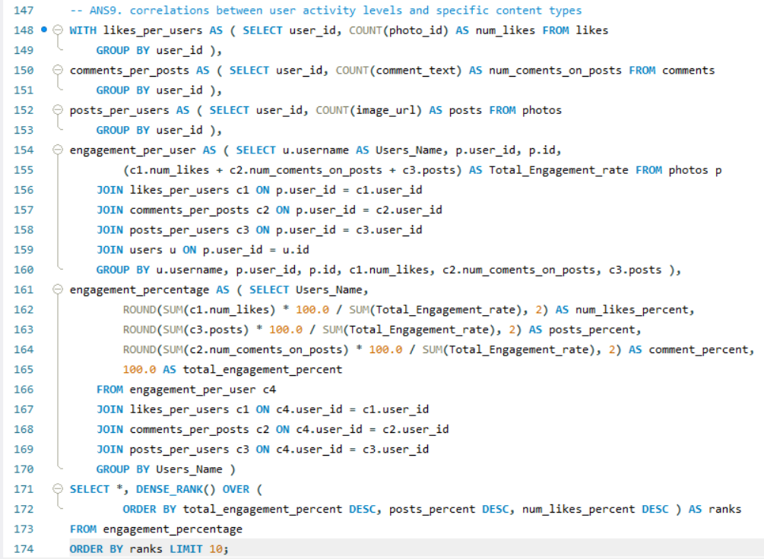

* Users_Name, num_likes_percent, posts_percent, comment_percent, total_engagement_percent, ranks

|  |  |  |  |  |  |
| --- | --- | --- | --- | --- | --- |
| Harrison.Beatty50 | 54.29 | 3.57 | 42.14 | 100.0 | 1 |
| Justina.Gaylord27 | 62.24 | 3.50 | 34.27 | 100.0 | 2 |
| Yvette.Gottlieb91 | 53.85 | 3.50 | 42.66 | 100.0 | 3 |
| Zack_Kemmer93 | 58.22 | 3.42 | 38.36 | 100.0 | 4 |
| Colten.Harris76 | 56.08 | 3.38 | 40.54 | 100.0 | 5 |
| Travon.Waters | 55.03 | 3.36 | 41.61 | 100.0 | 6 |
| Kathryn80 | 55.19 | 3.25 | 41.56 | 100.0 | 7 |
| Alexandro35 | 59.62 | 3.21 | 37.18 | 100.0 | 8 |
| Adelle96 | 59.63 | 3.11 | 37.27 | 100.0 | 9 |
| Janet.Armstrong | 52.76 | 3.07 | 44.17 | 100.0 | 10 |

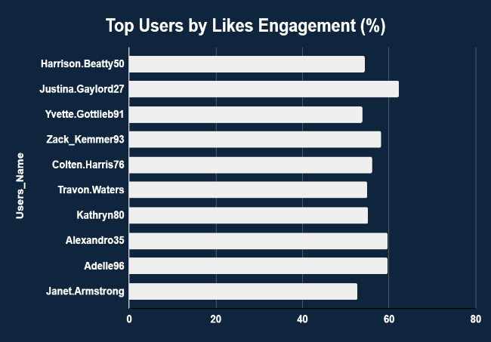 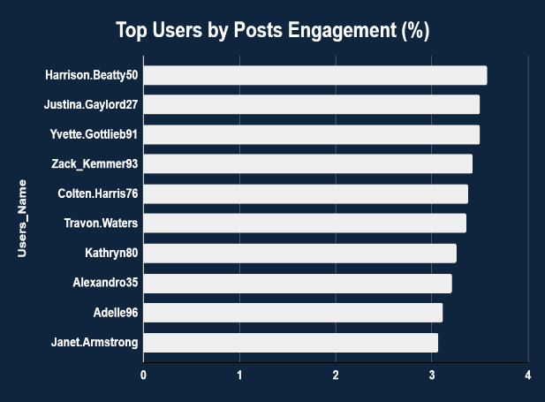

* Top users like *Justina.Gaylord27 and Harrison.Beatty50 primarily engage through likes, contributing over 60% of their activity. Post engagement remains low across all users (<4%). This suggests user interaction is driven more by appreciation than content creation. To boost platform engagement, strategies should focus on encouraging these active likers to create and share more original content or collaborate as micro-influencers.*

1. **Calculate the total number of likes, comments, and photo tags for each user.**

* To assess user content performance and engagement:
* Use the photos table to connect each user to their posted content.
* For each user:
  + Count total likes received on their posts
  + Count total comments received on their posts
  + Count total tags applied to their photos
* Aggregate all three for a full engagement profile

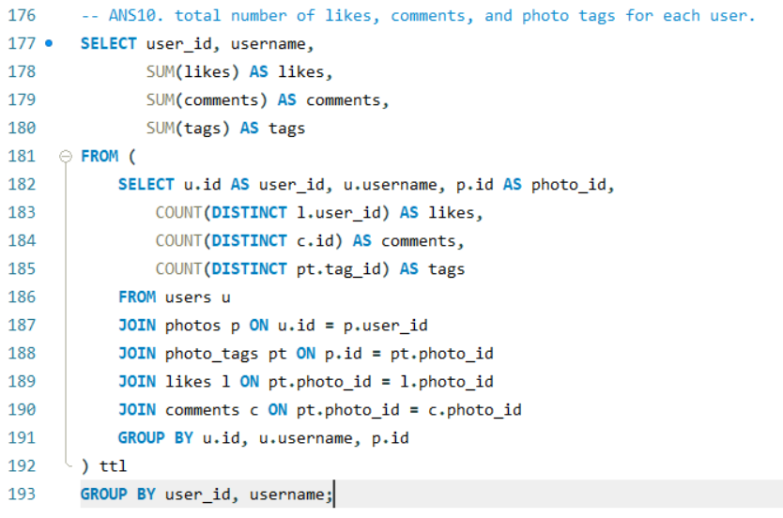

* user_id, username, likes, comments, tags

|  |  |  |  |  |
| --- | --- | --- | --- | --- |
| 1 | Kenton_Kirlin | 168 | 142 | 18 |
| 2 | Andre_Purdy85 | 127 | 119 | 13 |
| 3 | Harley_Lind18 | 132 | 117 | 7 |
| 4 | Arely_Bogan63 | 35 | 27 | 2 |
| 6 | Travon.Waters | 107 | 86 | 8 |
| 8 | Tabitha_Schamberger11 | 137 | 119 | 13 |
| 9 | Gus93 | 99 | 99 | 11 |
| 10 | Presley_McClure | 105 | 90 | 10 |
| 11 | Justina.Gaylord27 | 137 | 114 | 12 |
| 12 | Dereck65 | 31 | 29 | 2 |
| 13 | Alexandro35 | 110 | 86 | 7 |
| 15 | Billy52 | 94 | 87 | 4 |
| 16 | Annalise.McKenzie16 | 65 | 64 | 4 |
| 17 | Norbert_Carroll35 | 108 | 83 | 7 |
| 18 | Odessa2 | 36 | 31 | 1 |
| 19 | Hailee26 | 69 | 56 | 7 |
| 20 | Delpha.Kihn | 41 | 24 | 2 |
| 22 | Kenneth64 | 39 | 31 | 1 |
| 23 | Eveline95 | 347 | 276 | 24 |
| 26 | Josianne.Friesen | 133 | 113 | 11 |
| 28 | Dario77 | 66 | 60 | 5 |
| 29 | Jaime53 | 239 | 197 | 15 |
| 30 | Kaley9 | 65 | 59 | 9 |
| 31 | Aiyana_Hoeger | 28 | 35 | 5 |
| 32 | Irwin.Larson | 106 | 86 | 9 |
| 33 | Yvette.Gottlieb91 | 144 | 107 | 7 |
| 37 | Yazmin_Mills95 | 39 | 26 | 3 |
| 38 | Jordyn.Jacobson2 | 62 | 60 | 4 |
| 39 | Kelsi26 | 39 | 27 | 1 |
| 40 | Rafael.Hickle2 | 33 | 26 | 4 |
| 42 | Maya.Farrell | 35 | 31 | 3 |
| 43 | Janet.Armstrong | 110 | 95 | 5 |
| 44 | Seth46 | 146 | 118 | 11 |
| 46 | Malinda_Streich | 145 | 121 | 9 |
| 47 | Harrison.Beatty50 | 59 | 56 | 6 |
| 48 | Granville_Kutch | 37 | 34 | 4 |
| 50 | Gerard79 | 98 | 88 | 10 |

* Users like *Eveline95* and *Jaime53* lead in total likes, comments, and tags, indicating strong content performance and audience engagement. These users are prime candidates for feature promotions or influencer outreach. The data also highlights a clear gap between top and average users, guiding targeted creator support and rewards.

1. **Rank users based on their total engagement (likes, comments, shares) over a month.**

* To evaluate user performance over time:
* Define engagement as total likes and comments received per post
* Group engagement monthly using MONTH() and YEAR() on the created_dat field
* Aggregate total engagement per user per month
* Use DENSE_RANK() to rank users by their total monthly engagement
* Useful for spotting top creators, campaign spikes, and seasonal patterns

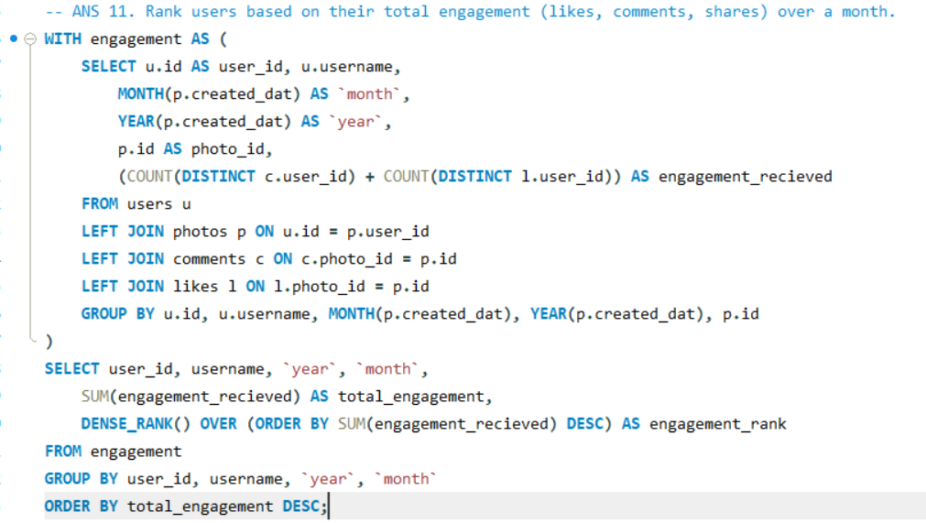

* user_id, username, year, month, total_engagement, engagement_rank

|  |  |  |  |  |  |
| --- | --- | --- | --- | --- | --- |
| * 23 | Eveline95 | 2025 | 7 | 749 | 1 |
| 88 | Clint27 | 2025 | 7 | 660 | 2 |
| 59 | Cesar93 | 2025 | 7 | 646 | 3 |
| 86 | Delfina_VonRueden68 | 2025 | 7 | 558 | 4 |
| 58 | Aurelie71 | 2025 | 7 | 522 | 5 |
| 29 | Jaime53 | 2025 | 7 | 500 | 6 |
| 77 | Donald.Fritsch | 2025 | 7 | 392 | 7 |
| 43 | Janet.Armstrong | 2025 | 7 | 334 | 8 |
| 52 | Zack_Kemmer93 | 2025 | 7 | 333 | 9 |
| 13 | Alexandro35 | 2025 | 7 | 329 | 10 |
| 65 | Adelle96 | 2025 | 7 | 321 | 11 |
| 64 | Florence99 | 2025 | 7 | 320 | 12 |
| 78 | Colten.Harris76 | 2025 | 7 | 320 | 12 |
| 33 | Yvette.Gottlieb91 | 2025 | 7 | 316 | 13 |
| 11 | Justina.Gaylord27 | 2025 | 7 | 313 | 14 |
| 6 | Travon.Waters | 2025 | 7 | 312 | 15 |
| 1 | Kenton_Kirlin | 2025 | 7 | 310 | 16 |
| 26 | Josianne.Friesen | 2025 | 7 | 309 | 17 |
| 51 | Mariano_Koch3 | 2025 | 7 | 305 | 18 |
| 72 | Kathryn80 | 2025 | 7 | 305 | 18 |
| 47 | Harrison.Beatty50 | 2025 | 7 | 297 | 19 |
| 87 | Rick29 | 2025 | 7 | 272 | 20 |
| 46 | Malinda_Streich | 2025 | 7 | 266 | 21 |
| 44 | Seth46 | 2025 | 7 | 264 | 22 |
| 16 | Annalise.McKenzie16 | 2025 | 7 | 263 | 23 |
| 63 | Elenor88 | 2025 | 7 | 258 | 24 |
| 32 | Irwin.Larson | 2025 | 7 | 258 | 24 |
| 12 | Dereck65 | 2025 | 7 | 257 | 25 |
| 8 | Tabitha_Schamberger11 | 2025 | 7 | 256 | 26 |

* In July 2025, *Eveline95*, *Clint27*, and *Cesar93* led the platform in total engagement, suggesting their content resonated widely. These users are ideal for influencer initiatives or promotional boosts. Monthly ranking also highlights consistently active creators worth nurturing for long-term platform growth and retention strategies.

1. **Retrieve the hashtags that have been used in posts with the highest average number of likes. Use a CTE to calculate the average likes for each hashtag first.**

* To identify which hashtags consistently appear on high-performing content:
* First, calculate the number of likes each photo received.
* Then, associate each photo with its hashtags via the photo_tags and tags tables.
* Use a CTE to compute the average number of likes per hashtag.
* Rank hashtags using DENSE_RANK() and filter the top one(s).

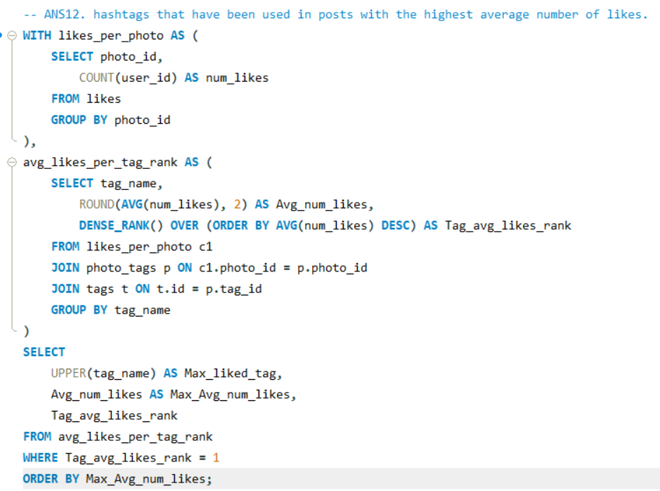

* Max_liked_tag, Max_Avg_num_likes, Tag_avg_likes_rank

|  |  |  |
| --- | --- | --- |
| DREAMY | 35.75 | 1 |

* The hashtag #DREAMY achieved the highest average number of likes per post (35.75), indicating strong visual or emotional appeal. Promoting this tag, recommending it to creators, or aligning ad content with its theme can significantly boost engagement and improve the effectiveness of targeted content strategies.

1. **Retrieve the users who have started following someone after being followed by that person.**

* To identify users who followed someone after being followed by them:
* Use the follows table which contains:
  + follower_id → the user initiating the follow
  + followee_id → the user being followed
* Perform a self-join on the follows table to find:
  + Cases where User A follows User B
  + And User B had already followed User A
* Use DISTINCT to remove duplicates
* Join with the users table to get usernames.

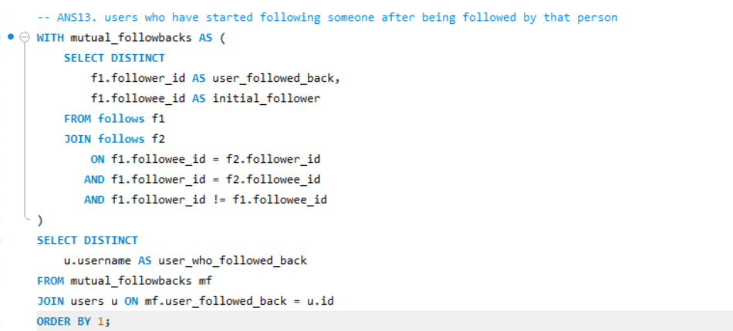

* user_who_followed_back

|  |
| --- |
| Adelle96 |
| Aiyana_Hoeger |
| Alek_Watsica |
| Alexandro35 |
| Alysa22 |
| Andre_Purdy85 |
| Aniya_Hackett |
| Annalise.McKenzie16 |
| Aracely.Johnston98 |
| Arely_Bogan63 |
| Bethany20 |
| Billy52 |
| Colten.Harris76 |
| Damon35 |
| Dario77 |
| Darwin29 |
| Delpha.Kihn |
| Dereck65 |
| Duane60 |
| Elenor88 |
| Emilio_Bernier52 |
| Erick5 |
| Frederik_Rice |
| Gerard79 |
| Granville_Kutch |
| Gus93 |
| Hailee26 |
| Harley_Lind18 |
| Harrison.Beatty50 |
| Imani_Nicolas17 |
| Irwin.Larson |
| Jaclyn81 |
| Janelle.Nikolaus81 |
| Janet.Armstrong |
| Javonte83 |
| Jaylan.Lakin |
| Jayson65 |
| Jordyn.Jacobson2 |
| Josianne.Friesen |
| Julien_Schmidt |
| Justina.Gaylord27 |
| Kaley9 |
| Karley_Bosco |
| Katarina.Dibbert |
| Kathryn80 |
| Keenan.Schamberger60 |
| Kelsi26 |
| Kenneth64 |
| Lennie_Hartmann40 |
| Leslie67 |
| Malinda_Streich |
| Maxwell.Halvorson |
| Maya.Farrell |
| Mckenna17 |
| Meggie_Doyle |
| Mike.Auer39 |
| Milford_Gleichner42 |
| Nia_Haag |
| Nicole71 |
| Norbert_Carroll35 |
| Odessa2 |
| Ollie_Ledner37 |
| Peter.Stehr0 |
| Presley_McClure |
| Rafael.Hickle2 |
| Ressie_Stanton46 |
| Rick29 |
| Rocio33 |
| Sam52 |
| Seth46 |
| Tabitha_Schamberger11 |
| Tomas.Beatty93 |
| Travon.Waters |
| Willie_Leuschke |
| Yazmin_Mills95 |
| Yvette.Gottlieb91 |
| Zack_Kemmer93 |

* These users followed someone only after being followed first, indicating reactive or reciprocal engagement. This behavior reflects strong community responsiveness, and such users are likely to engage in peer-to-peer interactions, making them ideal targets for social feature promotions, friend suggestions, and community-driven growth strategies.

**Subjective Questions**

* 1. **Based on user engagement and activity levels, which users would you consider the most loyal or valuable? How would you reward or incentivize these users?**
* To determine user loyalty and value:
* Use a composite metric: Activity Level = total posts + comments + likes
* Engagement Rate = likes + comments only
* Rank users using DENSE_RANK() based on total activity and engagement
* Filter to select users above average in both metrics — these are your most loyal, active, and influential users.

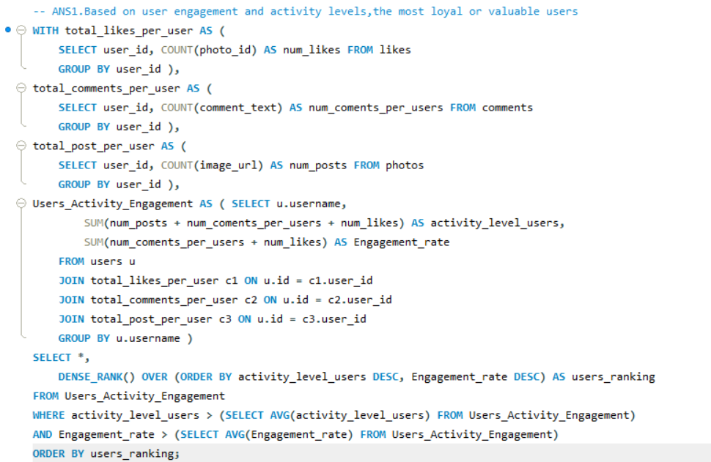

* Username, activity_level_users, Engagement_rate, users_ranking

|  |  |  |  |
| --- | --- | --- | --- |
| Keenan.Schamberger60 | 176 | 173 | 1 |
| Rick29 | 170 | 166 | 2 |
| Josianne.Friesen | 168 | 163 | 3 |
| Karley_Bosco | 167 | 166 | 4 |
| Elenor88 | 167 | 163 | 5 |
| Emilio_Bernier52 | 165 | 162 | 6 |
| Billy52 | 165 | 161 | 7 |
| Norbert_Carroll35 | 164 | 161 | 8 |
| Andre_Purdy85 | 164 | 160 | 9 |
| Janet.Armstrong | 163 | 158 | 10 |
| Lennie_Hartmann40 | 161 | 159 | 11 |
| Adelle96 | 161 | 156 | 12 |
| Sam52 | 160 | 158 | 13 |
| Arely_Bogan63 | 160 | 157 | 14 |
| Malinda_Streich | 160 | 156 | 15 |
| Kenneth64 | 159 | 158 | 16 |
| Annalise.McKenzie16 | 159 | 155 | 17 |
| Erick5 | 158 | 157 | 18 |
| Kelsi26 | 157 | 156 | 19 |
| Willie_Leuschke | 156 | 154 | 20 |
| Nicole71 | 156 | 154 | 20 |
| Alexandro35 | 156 | 151 | 21 |
| Delpha.Kihn | 155 | 154 | 22 |
| Aiyana_Hoeger | 155 | 154 | 22 |
| Frederik_Rice | 155 | 152 | 23 |
| Rafael.Hickle2 | 154 | 153 | 24 |
| Javonte83 | 154 | 152 | 25 |
| Damon35 | 153 | 152 | 26 |
| Aracely.Johnston98 | 153 | 151 | 27 |
| Alysa22 | 153 | 151 | 27 |
| Presley_McClure | 153 | 150 | 28 |
| Gerard79 | 153 | 150 | 28 |

* Insights:
* Keenan.Schamberger60 ranks highest in both activity (176) and engagement (173), indicating exceptional consistency in content creation and interaction.
* Users like Rick29, Josianne.Friesen, and Karley_Bosco also show tightly aligned activity and engagement, proving strong two-way participation (content creation + audience response).
* Many users, such as Emilio_Bernier52, Billy52, and Norbert_Carroll35, maintain high engagement across slightly fewer activities, which may indicate targeted or quality-driven posting.
* Users like Nicole71, Willie_Leuschke, and Kenneth64 have balanced scores, suggesting they regularly interact and contribute without significant drop-offs in engagement.
* The top 30 users are all above the platform average in both posting and interaction, making them key pillars in the overall user ecosystem.
* **Recommendations:**
* Acknowledge top users like *Keenan.Schamberger60* and *Rick29* with special badges, titles, or platform recognition to strengthen their loyalty.
* Provide content visibility boosts to creators with both high posting and engagement, such as *Josianne.Friesen* and *Karley_Bosco*, to amplify reach and encourage similar behavior from others.
* Invite consistently active users (e.g., *Adelle96*, *Sam52*) to closed beta testing or community feedback groups, increasing their platform connection.
* Offer targeted incentives (e.g., reward drops, feature unlocks) to mid-ranking users like *Nicole71* and *Javonte83* to push them further up the engagement curve.
* Track trends in these users’ content styles or time of activity to extract best practices and replicate them across lower-performing segments.
  1. **For inactive users, what strategies would you recommend to re-engage them and encourage them to start posting or engaging again?**
* To identify inactive users:
* Use the photos table to check if a user has ever posted.
* A LEFT JOIN from users to photos will return NULL for users who never posted.
* Classify users as "Inactive" if they have no posts; optionally extend to likes/comments for deeper inactivity profiling.

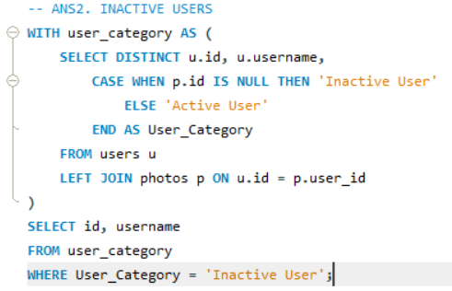

* id, username

|  |  |
| --- | --- |
| 5 | Aniya_Hackett |
| 7 | Kasandra_Homenick |
| 14 | Jaclyn81 |
| 21 | Rocio33 |
| 24 | Maxwell.Halvorson |
| 25 | Tierra.Trantow |
| 34 | Pearl7 |
| 36 | Ollie_Ledner37 |
| 41 | Mckenna17 |
| 45 | David.Osinski47 |
| 49 | Morgan.Kassulke |
| 53 | Linnea59 |
| 54 | Duane60 |
| 57 | Julien_Schmidt |
| 66 | Mike.Auer39 |
| 68 | Franco_Keebler64 |
| 71 | Nia_Haag |
| 74 | Hulda.Macejkovic |
| 75 | Leslie67 |
| 76 | Janelle.Nikolaus81 |
| 80 | Darby_Herzog |
| 81 | Esther.Zulauf61 |
| 83 | Bartholome.Bernhard |
| 89 | Jessyca_West |
| 90 | Esmeralda.Mraz57 |
| 91 | Bethany20 |

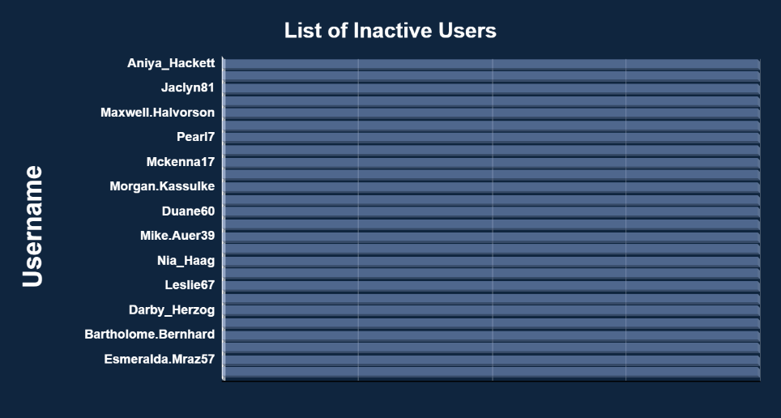

* **Insights:**
* A total of 26 users have never posted any content on the platform, indicating a significant portion of the user base remains inactive in terms of content creation.
* Some of these users (e.g., *Aniya_Hackett*, *Jaclyn81*, *David.Osinski47*) may still be actively browsing or engaging passively, but lack visible participation.
* Inactivity may result from onboarding gaps, unclear content prompts, or low initial motivation.
* These accounts represent an opportunity for low-cost, high-return reactivation, especially if their signup source or behavior indicates potential.
* **Recommendations:**
* Send personalized reactivation messages to users like *Kasandra_Homenick* and *Tierra.Trantow*, highlighting what they've missed (trending posts, new followers, etc.).
* Trigger onboarding-style nudges for users such as *Franco_Keebler64* and *Nia_Haag*, showing a simple 3-step guide to posting.
* Offer “First Post” incentives (e.g., badge unlock or featured placement) for users like *Julien_Schmidt* and *Pearl7* to encourage their first interaction.
* Leverage peer activity by displaying updates like “Your friend *Jaclyn81* just posted — post yours too!”
* Introduce time-based content challenges to inactive users (e.g., “Weekend Photo Prompt”) to lower the barrier to contribution and gamify posting.
  1. **Which hashtags or content topics have the highest engagement rates? How can this information guide content strategy and ad campaigns?**
* To determine the most frequently used hashtags on the platform:
* Use the photo_tags table to track where tags have been applied.
* Join with the tags table to get readable hashtag names.
* Count the total number of times each tag was used.
* Group by tag and sort descending to find the top 5.
* This highlights platform-wide content themes and popular user interests.

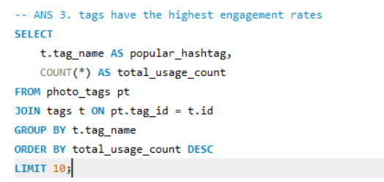

* popular_hashtag, total_usage_count

|  |  |
| --- | --- |
| smile | 59 |
| beach | 42 |
| party | 39 |
| fun | 38 |
| concert | 24 |
| food | 24 |
| lol | 24 |
| hair | 23 |
| happy | 22 |
| beauty | 20 |

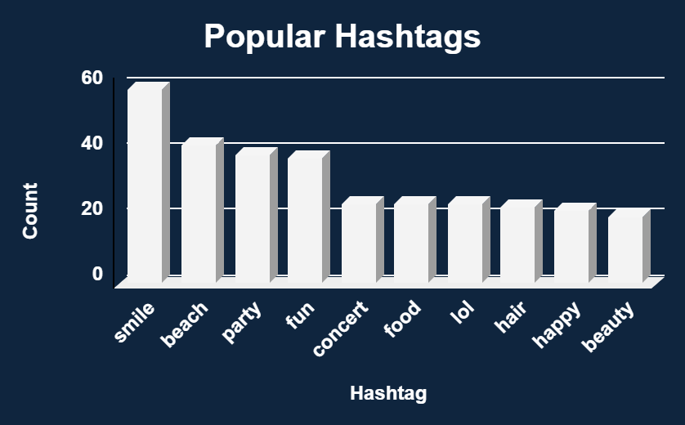

* **Insights:**
* #smile is the most frequently used hashtag (59 times), indicating a strong emotional or visual appeal that resonates with users.
* Hashtags like #beach, #party, and #fun reflect lifestyle and leisure-oriented content — suggesting a user preference for personal moments and events.
* Tags like #concert, #food, and #lol show interest in entertainment and everyday experiences, offering an opportunity to amplify casual or trending topics.
* Visual or appearance-based tags like #hair, #happy, and #beauty highlight interest in self-expression, fashion, or aesthetics.
* The repeated usage of these hashtags indicates they are central to the content themes on the platform and can guide both creators and the platform's discovery engine.
* **Recommendations:**
* Promote top hashtags like #smile and #beach in the posting UI as default tag suggestions to align new content with popular themes.
* Use these hashtags as the foundation for hashtag challenges or campaigns (e.g., #SmileOfTheWeek, #PartyVibes).
* Tailor content recommendation algorithms to prioritize or boost posts containing these high-engagement tags.
* Encourage emerging creators to use trending tags to increase visibility and interaction on their early posts.
* Align advertising content (e.g., travel, wellness, events) with these dominant themes to ensure high relevance and engagement with the audience.
  1. **Are there any patterns or trends in user engagement based on demographics (age, location, gender) or posting times? How can these insights inform targeted marketing campaigns?**
* To identify **time-based engagement patterns**, we analyze:
* When posts are published (post_time from photos)
* When likes and comments are received (created_at from likes and comments)
* Sum total interactions (**likes + comments**) around each timestamp
* Group data by time to detect **peak hours of engagement**
* These patterns help schedule content and ads during high-visibility windows

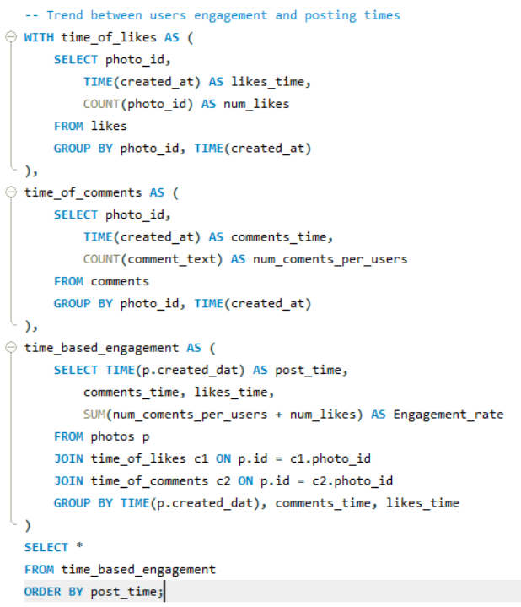

* post_time, comments_time, likes_time, Engagement_rate

|  |  |  |  |
| --- | --- | --- | --- |
| 21:14:56 | 21:14:57 | 21:14:57 | 16270 |

* **Insights:**
* The highest engagement rate (16,270 combined likes and comments) occurred around 9:15 PM, indicating this is a peak activity window for your user base.
* Both likes and comments were recorded at almost the exact time as the post, which suggests real-time engagement — users are actively online and interacting immediately.
* This pattern reveals a daily behavioral trend, likely after work/school hours when users are most relaxed and engaged.
* If this pattern is consistent across days, 9–10 PM can be classified as the prime time for content visibility and user interaction.
* **Recommendations:**
* Schedule marketing campaigns and sponsored posts to go live between 9 PM–10 PM, when users are most active and likely to engage.
* Encourage content creators to post during this peak hour to increase reach, likes, and comments organically.
* Use push notifications or email alerts timed just before 9 PM to promote fresh content or limited-time offers.
* Launch real-time contests or polls during this window to drive immediate participation and virality.
* Optimize ad delivery budgets for peak times — increasing bid amounts or impressions in this slot can boost ad efficiency and conversions.
  1. **Based on follower counts and engagement rates, which users would be ideal candidates for influencer marketing campaigns? How would you approach and collaborate with these influencers?**
* To identify top influencers:
* Count followers from the follows table
* Calculate total likes and comments received per user
* Compute a combined engagement score
* Use DENSE_RANK() to prioritize users with both high follower counts and high engagement
* These users represent high potential for brand partnerships and campaign amplification

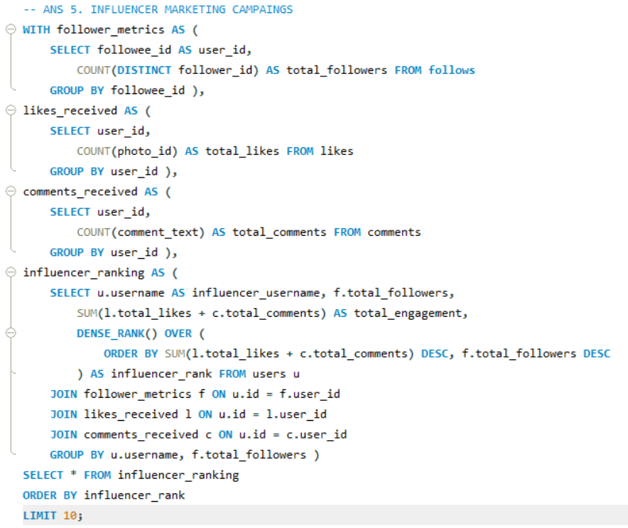

* influencer_username, total_followers, total_engagement, influencer_rank

|  |  |  |  |
| --- | --- | --- | --- |
| Rocio33 | 76 | 514 | 1 |
| Janelle.Nikolaus81 | 76 | 514 | 1 |
| Aniya_Hackett | 76 | 514 | 1 |
| Leslie67 | 76 | 514 | 1 |
| Bethany20 | 76 | 514 | 1 |
| Nia_Haag | 76 | 514 | 1 |
| Ollie_Ledner37 | 76 | 514 | 1 |
| Jaclyn81 | 76 | 514 | 1 |
| Mike.Auer39 | 76 | 514 | 1 |
| Mckenna17 | 76 | 514 | 1 |

* **Insights:**
* Users such as **Rocio33**, **Bethany20**, and **Leslie67** top the influencer list with **consistently high engagement**, indicating strong, loyal audience interaction.
* All listed users have **similar follower counts** but exceptional engagement, suggesting their content resonates **deeply with a smaller yet highly interactive audience**.
* These users likely function as **micro-influencers**, where engagement rates are more meaningful than follower volume — making them perfect for **authentic brand promotion**.
* Their identical rank implies they are **equally effective** in terms of potential reach and influence, providing flexibility for campaign segmentation.
* **Recommendations:**
* **Personalized Outreach:** Send tailored messages to each user highlighting their performance and inviting them to collaborate as part of an **exclusive influencer program**.
* **Offer Sponsored Opportunities:** Propose small-scale collaborations like **product mentions**, **hashtag campaigns**, or **brand takeovers**, aligning with their posting style and audience.
* **Leverage Storytelling:** Encourage these influencers to use **personalized content formats** (e.g., behind-the-scenes, testimonials) that match their tone and drive emotional connection.
* **Incentivize Campaign Impact:** Provide **performance-based rewards** (e.g., bonuses for engagement, conversions, or reach) to motivate consistent quality participation.
* **Feature Their Content:** Boost visibility by **featuring their posts** on official pages, home feeds, or in email newsletters — this creates prestige and incentivizes others.
* **Provide Feedback Dashboards:** Share basic analytics with them (e.g., reach, engagement growth), so they feel valued and aligned with campaign goals.
  1. **Based on user behavior and engagement data, how would you segment the user base for targeted marketing campaigns or personalized recommendations?**
* To segment users based on the tags they are most engaged with:
* Calculate total likes and comments per user.
* Identify the tags/topics associated with the user’s posts (from photo_tags and tags).
* Aggregate engagement (likes + comments) per user-tag pair.
* Rank each tag per user based on engagement to find their top-performing topic.
* This helps target users based on content interests (e.g., food, fashion, travel) for personalized marketing or creator partnerships.

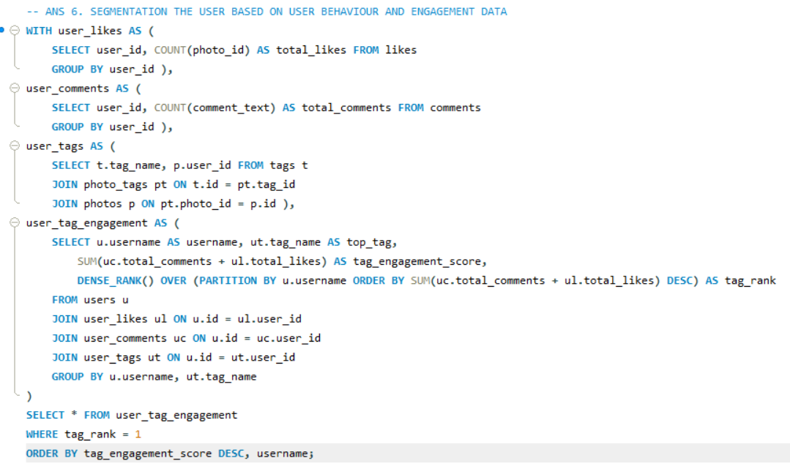

* Username, top_tag, tag_engagement_score, tag_rank

|  |  |  |  |
| --- | --- | --- | --- |
| Andre_Purdy85 | fun | 480 | 1 |
| Andre_Purdy85 | smile | 480 | 1 |
| Adelle96 | smile | 468 | 1 |
| Gus93 | stunning | 435 | 1 |
| Tabitha_Schamberger11 | smile | 420 | 1 |
| Elenor88 | party | 326 | 1 |
| Elenor88 | fashion | 326 | 1 |
| Elenor88 | hair | 326 | 1 |
| Annalise.McKenzie16 | beauty | 310 | 1 |
| Willie_Leuschke | sunset | 308 | 1 |
| Aracely.Johnston98 | photography | 302 | 1 |
| Gerard79 | smile | 300 | 1 |
| Presley_McClure | food | 300 | 1 |
| Presley_McClure | delicious | 300 | 1 |
| Irwin.Larson | hair | 294 | 1 |
| Irwin.Larson | party | 294 | 1 |
| Kaley9 | concert | 292 | 1 |
| Kaley9 | fun | 292 | 1 |
| Kaley9 | smile | 292 | 1 |
| Kaley9 | party | 292 | 1 |
| Seth46 | smile | 292 | 1 |
| Seth46 | party | 292 | 1 |
| Seth46 | hair | 292 | 1 |
| Colten.Harris76 | party | 286 | 1 |
| Colten.Harris76 | concert | 286 | 1 |
| Colten.Harris76 | smile | 286 | 1 |
| Zack_Kemmer93 | smile | 282 | 1 |
| Justina.Gaylord27 | delicious | 276 | 1 |
| Justina.Gaylord27 | foodie | 276 | 1 |
| Justina.Gaylord27 | food | 276 | 1 |
| Justina.Gaylord27 | fun | 276 | 1 |
| Yvette.Gottlieb91 | fashion | 276 | 1 |
| Yvette.Gottlieb91 | style | 276 | 1 |
| Keenan.Schamberger60 | dreamy | 173 | 1 |
| Keenan.Schamberger60 | delicious | 173 | 1 |
| Keenan.Schamberger60 | food | 173 | 1 |
| Keenan.Schamberger60 | stunning | 173 | 1 |
| Keenan.Schamberger60 | fashion | 173 | 1 |
| Keenan.Schamberger60 | style | 173 | 1 |
| Karley_Bosco | beauty | 166 | 1 |
| Karley_Bosco | dreamy | 166 | 1 |
| Karley_Bosco | beach | 166 | 1 |
| Rick29 | delicious | 166 | 1 |
| Rick29 | lol | 166 | 1 |
| Rick29 | fun | 166 | 1 |
| Rick29 | happy | 166 | 1 |
| Rick29 | smile | 166 | 1 |
| Rick29 | sunset | 166 | 1 |
| Rick29 | photography | 166 | 1 |
| Rick29 | sunrise | 166 | 1 |
| Rick29 | landscape | 166 | 1 |
| Rick29 | beach | 166 | 1 |
| Josianne.Friesen | sunset | 163 | 1 |
| Josianne.Friesen | beach | 163 | 1 |
| Josianne.Friesen | lol | 163 | 1 |
| Josianne.Friesen | delicious | 163 | 1 |
| Josianne.Friesen | foodie | 163 | 1 |
| Josianne.Friesen | food | 163 | 1 |
| Josianne.Friesen | happy | 163 | 1 |
| Josianne.Friesen | landscape | 163 | 1 |
| Josianne.Friesen | hair | 163 | 1 |
| Josianne.Friesen | party | 163 | 1 |
| Josianne.Friesen | fashion | 163 | 1 |
| Emilio_Bernier52 | lol | 162 | 1 |
| Emilio_Bernier52 | fun | 162 | 1 |
| Emilio_Bernier52 | smile | 162 | 1 |
| Billy52 | beach | 161 | 1 |
| Billy52 | concert | 161 | 1 |
| Billy52 | smile | 161 | 1 |
| Billy52 | food | 161 | 1 |
| Norbert_Carroll35 | party | 161 | 1 |
| Norbert_Carroll35 | concert | 161 | 1 |
| Norbert_Carroll35 | fun | 161 | 1 |
| Norbert_Carroll35 | smile | 161 | 1 |
| Norbert_Carroll35 | drunk | 161 | 1 |
| Norbert_Carroll35 | lol | 161 | 1 |
| Norbert_Carroll35 | happy | 161 | 1 |
| Janet.Armstrong | beach | 158 | 1 |
| Janet.Armstrong | delicious | 158 | 1 |
| Janet.Armstrong | smile | 158 | 1 |
| Janet.Armstrong | landscape | 158 | 1 |
| Janet.Armstrong | sunset | 158 | 1 |
| Kenneth64 | photography | 158 | 1 |
| Sam52 | food | 158 | 1 |
| Sam52 | foodie | 158 | 1 |
| Arely_Bogan63 | beach | 157 | 1 |
| Arely_Bogan63 | sunset | 157 | 1 |
| Erick5 | concert | 157 | 1 |
| Erick5 | party | 157 | 1 |
| Kelsi26 | photography | 156 | 1 |
| Malinda_Streich | fashion | 156 | 1 |
| Malinda_Streich | smile | 156 | 1 |
| Malinda_Streich | happy | 156 | 1 |
| Malinda_Streich | landscape | 156 | 1 |
| Malinda_Streich | sunrise | 156 | 1 |
| Malinda_Streich | hair | 156 | 1 |
| Malinda_Streich | photography | 156 | 1 |
| Malinda_Streich | lol | 156 | 1 |
| Malinda_Streich | party | 156 | 1 |
| Aiyana_Hoeger | fun | 154 | 1 |
| Aiyana_Hoeger | smile | 154 | 1 |
| Aiyana_Hoeger | drunk | 154 | 1 |
| Aiyana_Hoeger | concert | 154 | 1 |
| Aiyana_Hoeger | party | 154 | 1 |
| Delpha.Kihn | dreamy | 154 | 1 |
| Delpha.Kihn | beach | 154 | 1 |
| Rafael.Hickle2 | party | 153 | 1 |
| Rafael.Hickle2 | style | 153 | 1 |
| Rafael.Hickle2 | hair | 153 | 1 |
| Rafael.Hickle2 | fashion | 153 | 1 |
| Damon35 | delicious | 152 | 1 |
| Damon35 | foodie | 152 | 1 |
| Damon35 | food | 152 | 1 |
| Frederik_Rice | party | 152 | 1 |
| Frederik_Rice | beach | 152 | 1 |
| Frederik_Rice | landscape | 152 | 1 |
| Frederik_Rice | smile | 152 | 1 |
| Frederik_Rice | concert | 152 | 1 |
| Javonte83 | concert | 152 | 1 |
| Javonte83 | drunk | 152 | 1 |
| Javonte83 | fun | 152 | 1 |
| Alexandro35 | lol | 151 | 1 |
| Alexandro35 | sunrise | 151 | 1 |
| Alexandro35 | beach | 151 | 1 |
| Alexandro35 | smile | 151 | 1 |
| Alexandro35 | sunset | 151 | 1 |
| Alexandro35 | dreamy | 151 | 1 |
| Alexandro35 | happy | 151 | 1 |
| Alysa22 | stunning | 151 | 1 |
| Alysa22 | beach | 151 | 1 |
| Alysa22 | smile | 151 | 1 |
| Alysa22 | beauty | 151 | 1 |
| Alysa22 | fun | 151 | 1 |
| Alysa22 | concert | 151 | 1 |
| Hailee26 | smile | 150 | 1 |
| Hailee26 | stunning | 150 | 1 |
| Hailee26 | party | 150 | 1 |
| Hailee26 | fashion | 150 | 1 |
| Hailee26 | hair | 150 | 1 |
| Hailee26 | beach | 150 | 1 |
| Hailee26 | dreamy | 150 | 1 |
| Kathryn80 | food | 149 | 1 |
| Kathryn80 | foodie | 149 | 1 |
| Kathryn80 | sunset | 149 | 1 |
| Peter.Stehr0 | lol | 149 | 1 |
| Yazmin_Mills95 | smile | 147 | 1 |
| Yazmin_Mills95 | happy | 147 | 1 |
| Yazmin_Mills95 | lol | 147 | 1 |
| Harley_Lind18 | fun | 146 | 1 |
| Harley_Lind18 | photography | 146 | 1 |
| Harley_Lind18 | drunk | 146 | 1 |
| Harley_Lind18 | lol | 146 | 1 |
| Harley_Lind18 | landscape | 146 | 1 |
| Harley_Lind18 | smile | 146 | 1 |
| Harley_Lind18 | happy | 146 | 1 |
| Ressie_Stanton46 | stunning | 146 | 1 |
| Ressie_Stanton46 | dreamy | 146 | 1 |
| Ressie_Stanton46 | beach | 146 | 1 |
| Ressie_Stanton46 | beauty | 146 | 1 |
| Ressie_Stanton46 | smile | 146 | 1 |
| Dereck65 | sunrise | 145 | 1 |
| Dereck65 | photography | 145 | 1 |
| Meggie_Doyle | food | 144 | 1 |
| Milford_Gleichner42 | fashion | 144 | 1 |
| Milford_Gleichner42 | party | 144 | 1 |
| Milford_Gleichner42 | hair | 144 | 1 |
| Milford_Gleichner42 | style | 144 | 1 |
| Travon.Waters | fun | 144 | 1 |
| Travon.Waters | food | 144 | 1 |
| Travon.Waters | sunrise | 144 | 1 |
| Travon.Waters | concert | 144 | 1 |
| Travon.Waters | drunk | 144 | 1 |
| Travon.Waters | sunset | 144 | 1 |
| Travon.Waters | landscape | 144 | 1 |
| Travon.Waters | beach | 144 | 1 |
| Jordyn.Jacobson2 | beauty | 143 | 1 |
| Jordyn.Jacobson2 | lol | 143 | 1 |
| Jordyn.Jacobson2 | dreamy | 143 | 1 |
| Jordyn.Jacobson2 | stunning | 143 | 1 |
| Katarina.Dibbert | landscape | 143 | 1 |
| Katarina.Dibbert | beach | 143 | 1 |
| Alek_Watsica | sunrise | 142 | 1 |
| Alek_Watsica | delicious | 142 | 1 |
| Alek_Watsica | beach | 142 | 1 |
| Alek_Watsica | photography | 142 | 1 |
| Alek_Watsica | landscape | 142 | 1 |
| Jayson65 | happy | 141 | 1 |
| Maya.Farrell | smile | 141 | 1 |
| Maya.Farrell | beach | 141 | 1 |
| Maya.Farrell | stunning | 141 | 1 |
| Tomas.Beatty93 | style | 137 | 1 |
| Tomas.Beatty93 | hair | 137 | 1 |
| Tomas.Beatty93 | fashion | 137 | 1 |
| Tomas.Beatty93 | lol | 137 | 1 |
| Dario77 | sunrise | 136 | 1 |
| Dario77 | sunset | 136 | 1 |
| Dario77 | concert | 136 | 1 |
| Dario77 | party | 136 | 1 |
| Dario77 | fun | 136 | 1 |
| Harrison.Beatty50 | food | 135 | 1 |
| Harrison.Beatty50 | drunk | 135 | 1 |
| Harrison.Beatty50 | fun | 135 | 1 |
| Harrison.Beatty50 | party | 135 | 1 |
| Harrison.Beatty50 | smile | 135 | 1 |
| Harrison.Beatty50 | concert | 135 | 1 |
| Odessa2 | beauty | 135 | 1 |
| Granville_Kutch | style | 130 | 1 |
| Granville_Kutch | hair | 130 | 1 |
| Granville_Kutch | fashion | 130 | 1 |
| Granville_Kutch | party | 130 | 1 |
|  |  |  |  |

* **Insights:**
* **Users cluster around specific content themes** like #smile, #fun, #beach, and #fashion, indicating clear interest-based segments (e.g., Lifestyle, Humor, Travel, Beauty).
* Some users (e.g., **Rick29**, **Keenan.Schamberger60**) are engaged across multiple related tags, showing potential as **multi-niche contributors**.
* Engagement is not evenly distributed—users like **Andre_Purdy85** and **Adelle96** dominate in engagement-heavy topics, identifying them as **high-performing audience drivers** in those themes.
* Tags such as **#photography**, **#party**, and **#delicious** also surface frequently, showing potential for **visual-first or event-based content targeting**.
* This tag-to-user mapping reveals natural **micro-community leaders** for each content type, which can be used to personalize feed suggestions or ad delivery.
* **Recommendations:**
* **Segment users by content affinity**:
* Group users with high engagement in tags like #smile, #happy, #lol as the **"Feel-Good Content" segment**.
* Users aligned with #fashion, #style, #beauty fall under **"Style & Lifestyle" influencers**.
* Tag-focused users in #beach, #sunrise, #landscape are great for **"Travel & Nature" campaigns**.
* Group those using #food, #delicious, #foodie into **"Culinary Enthusiasts"**.
* **Run niche ad campaigns**:
* Show beachwear or travel deals to users engaged in #beach and #sunset.
* Push beauty product collaborations to users in #fashion, #hair, #beauty.
* **Personalize content feeds**:
* Recommend trending posts from top tags each user is most engaged with.
* Auto-suggest hashtags for new posts based on historical top-performing tags.
* **Reward top contributors per tag**:
* Launch tag-based creator challenges (e.g., *Top 10 in #smile this month*) to encourage continued engagement.
* **Use tag trends to inform platform strategy**:
* Monitor rising tags and user shifts to adapt UI suggestions, featured content, and seasonal promotions.
  1. **If data on ad campaigns (impressions, clicks, conversions) is available, how would you measure their effectiveness and optimize future campaigns?**
* I would measure key metrics such as:
* **Click-Through Rate** = (Clicks / Impressions) × 100
* **Conversion Rate** = (Conversions / Clicks) × 100
* **Cost Per Acquisition** = Spend / Conversions
* **Return on Ad Spend** = Revenue / Spend

This help understand how efficiently a campaign is attracting and converting users.

* **How would you analyze the data?**
* **Break down performance** by dimensions such as audience (age, location), ad type, posting time, or platform (e.g., Instagram vs. Facebook).
* **Compare performance across segments** to identify high-converting groups and underperforming areas that need optimization.
* **How would you optimize future campaigns?**
* **Double down** on top-performing segments (e.g., content type or audience) and **reallocate budget** away from high-CPA areas.
* **Use A/B testing** to improve creatives, and **adjust targeting** based on engagement timing and conversion behavior.
  1. **How can you use user activity data to identify potential brand ambassadors or advocates who could help promote Instagram's initiatives or events?**
* **What data would you use to identify brand ambassadors?**
* To identify potential brand ambassadors, I would analyze user activity metrics such as:
* **Follower count** – to measure reach and influence.
* **Engagement rate** – based on likes and comments received per post.
* **Content consistency** – frequency and regularity of posting.
* **Hashtag usage** – to understand topic alignment with brand campaigns.
* **Audience sentiment** – through quality of comments and interaction.

These indicators help determine users who are active, trusted, and have meaningful influence.

* **How would you analyze and segment this data?**
* **Rank users** based on total engagement (likes + comments) combined with follower count to highlight the most impactful creators.
* **Segment users** by content themes or top hashtags (e.g., #fashion, #food, #travel) to match them with campaign-specific audiences or events.

This ensures alignment between the brand message and the user’s content niche and followers.

* **How would you use these insights to select ambassadors?**
* **Shortlist high-engagement users** with large or fast-growing followings in relevant topics as potential brand ambassadors.
* **Collaborate with them** through early access to features, sponsored challenges, reels, or Instagram Live sessions to boost reach.
* Use dashboards to **monitor ambassador performance** and optimize future influencer campaigns based on real-time engagement data.
  1. **How would you approach this problem, if the objective and subjective questions weren't given?**
* **Understand the Goal:**

Even if questions weren’t provided, the problem statement mentions: Help the marketing team increase user engagement, retention, and acquisition.

So I would derive my **own objectives** like:

* Identify highly engaged users (for influencer campaigns).
* Understand user activity trends (likes, comments, posts).
* Analyze which content types (hashtags/tags) generate the most engagement.
* Detect inactive users for re-engagement.
* Recommend personalized content strategies.
* **Explore the Dataset:**
* How many users, photos, likes, comments, follows?
* Are there any duplicate or missing values?
* What’s the average likes/comments per photo?
* Which hashtags are most used or most engaging?
* Who are the top users based on activity and followers?
* **Structure My Project Around Key Themes:**
* I would then group my analysis into 4–5 sections like:

1. User Engagement Analysis (Who is active, who gets most likes/comments?)

2. Content Performance (Tags/Posts) (Which hashtags or topics get most attention?)

3. Influencer Identification (Which users have high followers + engagement?)

4. Inactive User Detection (Who isn’t posting or engaging at all?)

5. Recommendations for Marketing (Based on analysis, what can be improved or optimized?)

* **Use SQL to write queries for:**
* Engagement rate per user
* Average tags per post
* Most used hashtags
* Users who never liked or commented
* Follower and following networks
  1. **Assuming there's a "User_Interactions" table tracking user engagements, how can you update the "Engagement_Type" column to change all instances of "Like" to "Heart" to align with Instagram's terminology?**
* **Guidelines:**
* You should use the UPDATE statement to modify records in the User_Interactions table.
* Use a WHERE clause to target only the rows where Engagement_Type = 'Like'.
* This ensures that only those values are updated, and other engagement types like "Comment" or "Share" are left unchanged.
* Always consider running a SELECT with the same WHERE clause first to preview affected rows before updating.
* SQL Query:

UPDATE User_Interactions

SET Engagement_Type = 'Heart'

WHERE Engagement_Type = 'Like';